Narrative:

In this assignment the effect of inhomogeneities on wells was investigated. The quantity of interest in this investigation was the maximum discharge of a well in an inhomogeneity. The maximum discharge of a well was calculated by setting the potential at the well’s screen equal to zero, indicating maximal drawdown.

The complex potential for a well in an inhomogeneity is



At maximum discharge, the potential at the wells screen is zero, so the real part of the above equation, evaluated at z = zw + rw (position of the well + radius of the well), can be solved from Q\_max. The same method will apply in the case that there is uniform flow, but the complex potential term must include the expression for uniform flow.

Q\_max depends on C, the constant. C is found by using the far field condition (a known potential at a faraway point) and the complex potential for a well in an inhomogeneity, outside the inhomogeneity:



This equation is evaluated with z = z far field, and the real part is equal to the far field potential. As described, the two equations have 2 unknowns, Q\_max and C, which can be solved for algebraically, giving the maximum discharge of a well in an inhomogeneity.

Using this method, the maximum discharge of various cases was investigated and the detailed results are shown below. Generally, wells in inhomogeneities of high hydraulic conductivity drastically increased the maximum well discharge relative to a well in a homogenous aquifer. Wells in low hydraulic conductivity zones had dramatically lower maximum discharge. The closer a well is to the center of an inhomogeneity, the greater the observed effect of the inhomogeneity on the maximum pumping rate. The addition of Uniform flow had little influence on the maximum pumping rate at these wells.

Case 1, no uniform flow

|  |  |
| --- | --- |
|  | Q\_max, m/d |
| K = k1 | 1.27 \* 10^3 |
| K1 = 10\* k | 5.31\* 10^4 |
| K= 10\* k1 | 72 |
|  |  |

Potential contours:

K=k1

C:\Users\Jack\AppData\Local\Microsoft\Windows\INetCache\Content.Word\Case1_k=k1.tif

K1>k

C:\Users\Jack\Documents\GW modeling\Original work\HW 4\figs\Case1_klessk1.tif

k>k1

C:\Users\Jack\Documents\GW modeling\Original work\HW 4\figs\Case1_kgreaterk1.tif

2.

For k1>>k

|  |  |
| --- | --- |
|  | Q max, m/d |
| Zw=0 | 5.31\* 10^4 |
| Zw=50 | 4.84 \* 10^3 |
| Zw=75 | 4.14 \* 10^4 |

For k1 << k

|  |  |
| --- | --- |
|  | Q max, m/d |
| Zw=0 | 72 |
| Zw=50 | 73 |
| Zw=75 | 75 |

The maximum discharge decreases slightly as the well is placed further from the center of the inhomogeity.

3.

For k1>k

|  |  |
| --- | --- |
| Radius of gravel pack, m | Qmax, m/d |
| .5 | 2.19 \* 10^4 |
| 1 | 2.37 \* 10^4 |
| 1.5 | 2.49 \* 10^4 |
| 3 | 2.73 \* 10^4 |
| 5 | 2.94 \* 10^4 |

The maximum discharge of the well increases somewhat as the size of the gravel pack around it increases.

Case 2, uniform flow left to right

|  |  |
| --- | --- |
|  | Q\_max, m/d |
| K = k1 | 1.27 \* 10^3 |
| K1 = 10\* k | 5.79 \* 10^4 |
| K= 10\* k1 | 6.79 |
|  |  |

Head contours:

K=k1

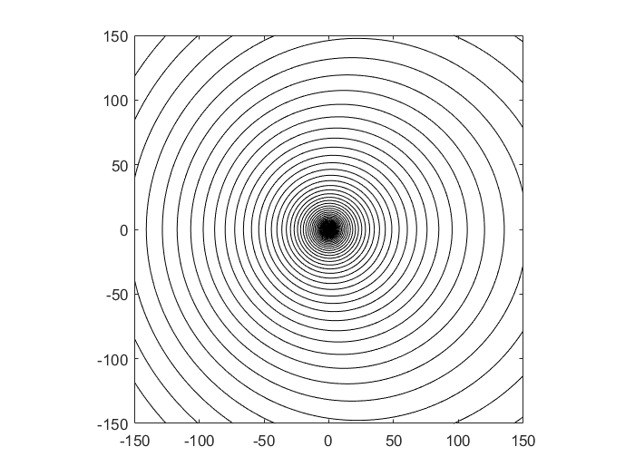

K1>k

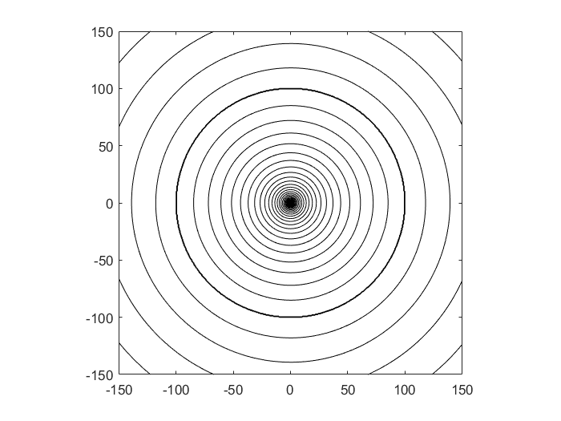

k>k1

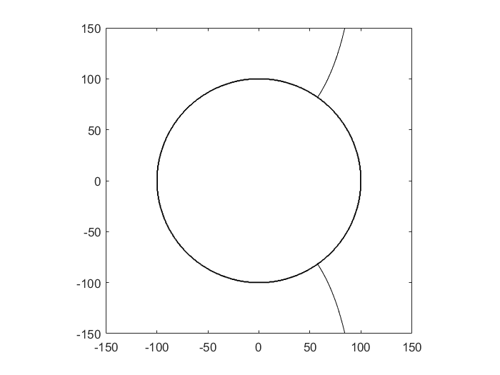

2.

For k1>>k

|  |  |
| --- | --- |
|  | Q max, m/d |
| Zw=0 | 5.79 \* 10^4 |
| Zw=50 | 5.25 \* 10^4 |
| Zw=75 | 4.48 \* 10^4 |

For k1 << k

|  |  |
| --- | --- |
|  | Q max, m/d |
| Zw=0 | 6.79 |
| Zw=50 | 6.19 |
| Zw=75 | 6.0 |

3.

For k1>k

|  |  |
| --- | --- |
| Radius of gravel pack, m | Qmax, m/d |
| .5 | 2.39 \* 10^4 |
| 1 | 2.59 \* 10^4 |
| 1.5 | 2.72 \* 10^4 |
| 3 | 2.92\* 10^4 |
| 5 | 3.212 \* 10^4 |

Code:

**Main.m**:

%case 1: no uniform flow

%Parameters

k = 10;

k1= 10; %m/d

zw =0;

rw = 0.05;

R = 100; %m

Rinf = 10\*R;

Qx0 = 0; %No uniform flow

PhiInf = .5 \* k \* 20\*20;

z = zw+rw;

%calculate maximum discharge

Q\_max = ((Qx0\*(z))\*(2\*k1/(k1+k))+ (-Qx0\* (Rinf -(k1-k)\*R\*R/((k1+k)\*Rinf)))- (k1/k)\*real(PhiInf))/ real((1/(2\*pi))\*log(z-zw)+ ((k1-k)/(k1+k))\*(1/(2\*pi)) \* log((conj(zw)\*(z)/-R) + R) - (2\*k/(k1+k))\* (1/(2\*pi))\*log(Rinf - zw) -((k1-k)/(k1+k))\*(1/(2\*pi))\*log(Rinf/R));

%calculate constant

c = real(PhiInf + (2\*k/(k1+k))\* (Q/(2\*pi))\*log(Rinf - zw) +((k1-k)/(k1+k))\*(Q/(2\*pi))\*log(Rinf/R)+ Qx0\* (Rinf -(k1-k)\*R\*R/((k1+k)\*Rinf)));

%Calculate Q max if there was no inhomogeneity

Q\_noInhomogeneity = -PhiInf /real( (1/(2\*pi))\*(log(zw+rw-zw) -log(Rinf - zw)) );

%Contour the real potential

ContourMe\_R\_int(-150,150,500, -150,150,500, @(z)real(Omega\_total(Qx0, z, k1,k,R, c,Q\_max,zw)),60);

%Case 2, uniform flow

%Parameters

k = 10;

k1= 100; %m/d

zw =0;

rw = 0.05;

R = 5; %m

Rinf = -10\*R;

Qx0= .5\*k\*(21\*21 - 19\*19)/(2 \* abs(Rinf)) ;%with uniform flow

PhiInf = .5 \* k \* 21\*21;

z = zw+rw;

Q\_max = ((Qx0\*(z))\*(2\*k1/(k1+k))+ (-Qx0\* (Rinf -(k1-k)\*R\*R/((k1+k)\*Rinf)))- (k1/k)\*real(PhiInf))/ real((1/(2\*pi))\*log(z-zw)+ ((k1-k)/(k1+k))\*(1/(2\*pi)) \* log((conj(zw)\*(z)/-R) + R) - (2\*k/(k1+k))\* (1/(2\*pi))\*log(Rinf - zw) -((k1-k)/(k1+k))\*(1/(2\*pi))\*log(Rinf/R))

c = real(PhiInf + (2\*k/(k1+k))\* (Q/(2\*pi))\*log(Rinf - zw) +((k1-k)/(k1+k))\*(Q/(2\*pi))\*log(Rinf/R)+ Qx0\* (Rinf -(k1-k)\*R\*R/((k1+k)\*Rinf)));

ContourMe\_R\_int(-150,150,500, -150,150,500, @(z)real(Omega\_total(Qx0, z, k1,k,R, c,Q\_max,zw)),60);

function [ Omega ] = Omega\_total(Qx0, z, k1,k,R,C,Q,zw )

%UNTITLED4 Summary of this function goes here

% Detailed explanation goes here

rsq=(z)\*conj(z);

if rsq>R^2

Omega = Omega\_outside(Qx0, z, k1,k,R, C,Q,zw);

else

Omega = Omega\_inside(Qx0, z, k1,k,R, C,Q,zw);

end

function [ Omega ] = Omega\_outside(Qx0, z, k1,k,R,C,Q ,zw)

%UNTITLED Summary of this function goes here

% Detailed explanation goes here

Omega = -Qx0\*(z-((k1-k)/(k1 +k))\*(R\*R)/z) + (2\*k/(k1+k))\*(Q/(2\*pi))\*log(z-zw) + ((k1-k)/(k1+k))\*(Q/(2\*pi))\*log(z/R) + real(C);

end

function [ Omega ] = Omega\_inside(Qx0, z, k1,k,R,C,Q,zw )

%UNTITLED2 Summary of this function goes here

% Detailed explanation goes here

Omega =( -2\*k1/(k1 + k))\*Qx0\*z +(Q/(2\*pi))\*log(z-zw)+ ((k1-k)/(k1+k))\*(Q/(2\*pi)) \* log(R - z\* conj(zw)/R) +(k1/k)\*real(C);

end

**ContourMe\_R\_int.m**

function [Grid] = ContourMe\_R\_int(xfrom, xto, Nx, yfrom, yto, Ny, func,nint)

%==========================================================================

% ContourMe(xfrom, xto, Nx, yfrom, yto, Ny, func) (01.23.09)

%

% Contour the real part of the specified complex function.

%

% Arguments:

%

% xfrom starting x-value for the domain

% xto ending x-value for the domain

% Nx number of grid columns

%

% yfrom starting y-value for the domain

% yto ending y-value for the domain

% Ny number of grid rows

%

% func function to contour; must take one complex argument.

%

% Returns:

%

% Grid Ny x Nx matrix of values of func at the rid nodes.

%

% Example Usage:

%

% G = ContourMe(1,2,11,1,2,11,@(z)Omega(1,-1,z));

%==========================================================================

Grid = zeros(Ny,Nx);

X = linspace(xfrom, xto, Nx);

Y = linspace(yfrom, yto, Ny);

for row = 1:Ny

for col = 1:Nx

Grid(row,col) = func( complex( X(col), Y(row) ) );

end

end

contour(X, Y, real(Grid),nint, 'k');

axis equal